**Practice Paper I For Unit Test 1**

**Subject: Computer Science**

**Topic: Number Systems, Boolean Algebra, Logic Gates, Propositional Logic, OOP in Java**

**Time:** 12 Hours     **Full Marks:** 80 (Maybe)

**Section A – Number Systems and Binary Arithmetic (10 Marks)**

**1. Convert the following: (5 × 1 = 5)**  
a) (101101)₂ to Decimal  
b) (79)₁₀ to Binary  
c) (17)₈ to Binary  
d) (11010110)₂ to Hexadecimal  
e) (2F)₁₆ to Decimal

**2. Perform the following binary operations: (2 × 1.5 = 3)**  
a) 1011 + 1101   
b) 1101 – 1001 (using 2’s complement)  
c) 10101 × 110

**3. Decode the following 4-bit binary numbers into hexadecimal: (1 × 2 = 2)**  
(0001, 0101, 0111, 1000, 1010, 1100, 1110, 1111)

**Section B – Boolean Algebra & Logic Gates (24 Marks)**

**4. Find the complement of the Boolean expression: A′ • (B • C′ + B′ • C) [1 mark]**  
 (a) A′ • (B + C + B′ + C)  
 (b) A + (B + C′) • (B + C′)  
 (c) A + (B′ + C) • (B + C′)  
 (d) A′ • (B′ + C′ + B′ • C)

**5. According to the Principle of Duality, the Boolean equation [1 mark]**  
(A′ + B) • (1 + B) = A′ + B  is equivalent to:  
 (a) (A + B′) • (0 + B) = A + B′  
 (b) (A′ • B) + (0 • B) = A′ • B  
 (c) (A′ • B) + (0 • B) = A′ + B  
 (d) (A′ + B) • (0 + B) = A′ + B

**6. Distributive law states that: [1 mark]  
 (a) A + B • C = (A + B) • (A + C)  
 (b) A + (A • B) = A  
 (c) A • (B + C) = (A • B) + (B • C)  
 (d) A + B • C = A • B + A • C**

**7. Logic Expression and Circuit: (3 marks)**  
i) Write the logic expression:

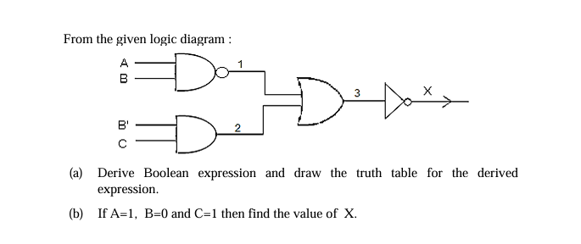

ii) **X = (A + B′) • (C + D′)**  
 Draw the logic circuit diagram for the above.

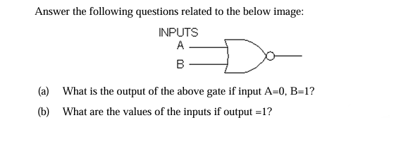iii)

**8. Real-life Logical Expression – (6 marks)**  
A shopping mall announces a special discount on all its products as a festival offer only to those who satisfy any one of the following conditions.

• If he/she is an employee of the mall and has a service of more than 10 years.

OR

• A regular customer of the mall whose age is less than 65 years and should not be an employee of the mall.

OR

• If he/she is a senior citizen but not a regular customer of the mall.

(The inputs are : INPUTS **E Employee of the mall**, **R Regular customer of the mall,**  **S Service of the employee is more than 10 years, C Senior citizen of 65 years or above** (In all the above cases, 1 indicates yes and 0 indicates no.) (i) Draw the truth table for X(E, R, S, C).  
(ii) Write the Sum Of Products expression.  
(iii) Draw the logic gate diagram for the simplified expression.

**9. Verify using a truth table if the proposition is valid: (4 marks)**  
(X ∧ Y) ⇒ Z ≡ (Y ⇒ Z) ∧ (X ⇒ Y)

**10. Analyze the given propositions: (3 marks)**  
p = I am a triangle  
q = I am a three-sided polygon  
s1 = p → q  
s2 = q → p  
Assertion: s2 is converse of s1  
Reason: Three-sided polygon must be a triangle.  
Options:  
(a) Both A and R are true, and R is the correct explanation  
(b) Both A and R are true, but R is not the correct explanation  
(c) A is true, R is false  
(d) A is false, R is true

**Section C – Programming in Java (26 Marks)**

**11. Assertion-Reason Based Java Question: (2 marks)**  
Assertion: In Java, the String class is used to create and manipulate strings, and it is immutable.  
Reason: Immutability ensures that once a String object is created, its value cannot be changed.  
(a) Both A and R are true, and R is the correct explanation  
(b) Both A and R are true, but R is not the correct explanation  
(c) A is true, R is false  
(d) A is false, R is true

**12. Java Classes – Array Handling: (8 marks)**  
Define a class Mixarray with following:

* Data Members: arr[], cap
* Methods:  
   - Constructor to initialize cap  
   - void input() //accept array  
   - Mixarray mix(Mixarray P, Mixarray Q) //create new array with first 3 of P and Q  
   - void display() // show elements
* Define main() // to demonstrate functionality with sample inputs.

**13. Java Classes – LCM Calculation: (8 marks)**  
Define a class LCM with:

* Data Members: n1, n2, large, sm, l
* Methods:  
   - Constructor to initialize variables  
   - void accept() – take input  
   - int getLCM() – return LCM using recursion  
   - void display() – show values
* Define main() to create object and show results.  
  **Hint:** Use LCM(a, b) = (a × b) / GCD(a, b) with recursive GCD logic.